TI 22 – 64. Technology Example – UTROV Utility ROV tooling for Decommissioning
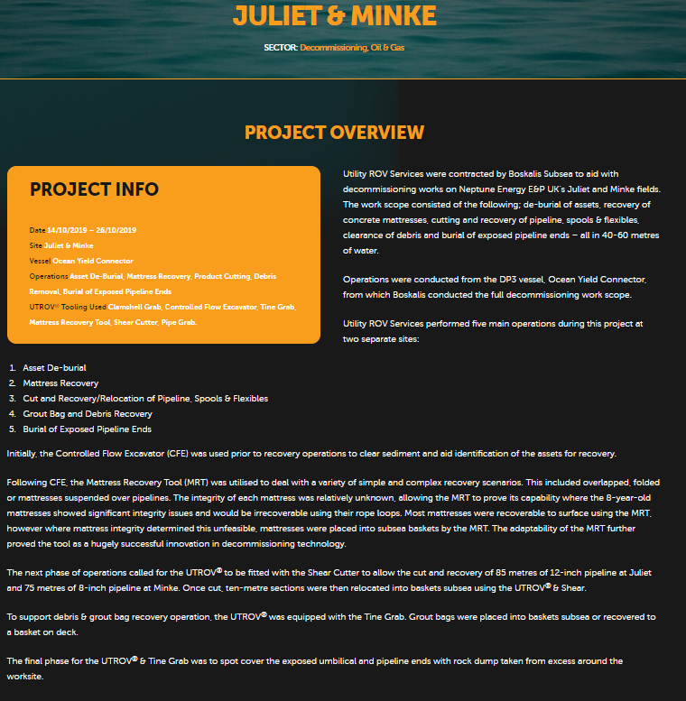
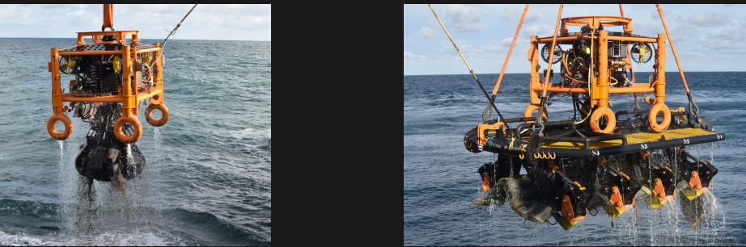
For further information on this technology Example click on the link below to go to the vendors website:
Link: Utility ROV Services » Juliet & Minke (utrov.com)

